**Minutes of Meeting**

IS203 Software Engineering **|** G7-T5 (SEvivor)

|  |  |
| --- | --- |
| **Date:** | 29 August 2016, Monday |
| **Time:** | 9.00 pm – 5.00 pm |
| **Venue:** | SIS CR 3-1 |
| **Scriber:** | Nilofar |
| **Attendees:** | Kong Yu Jian, Jackson Kwa, Marc Xu, Teh Ming Yi, M Has Nilofar |
|  |  |
| **Agenda:** | 1. Learn Twitter Bootstrap mainly and the technologies involved in a Web Application development project  2. Work on understanding all the project requirements, and start taking apart data requirements while working on database diagrams etc  3. Begin UI wireframing and start coding for UI |

|  |  |  |  |
| --- | --- | --- | --- |
|  | **Agenda** | **Action By** | **Due Date** |
| 1 | Learn to use bootstrap and other web technologies for great design in the creation of a web application.  - Can have html or jsp or php as a form of web pages  - Index.jsp/index.html: homepages [naming convention]  - Head tags: store libraries – JS or CSS libraries – can put a link and can be downloaded from somewhere else to be used in the html/.jsp file  - CDN: a server for a respective country for efficiency (use Singapore’s one for use in Sg)  - Go to [getbootstrap.com](http://getbootstrap.com/) and read the stuff there or W3Schools and StackOverflow when in doubt  - Try not to import JQuery lib from CDN (safety measure; just in case a CDN provider decides to not make its CDN available)  - Bootstrap elements that are VERY important:  – modify bootstrap element in a way or another; container: efficient design (to make the design not stick to the left)  - Responsive design (changes from a desktop view to a mobile device view)  - Merging two classes (execute left to right) styles will be overwritten  - 12 column in a row  - [Fontawesome.io](http://fontawesome.io/) – for icons - AdminLTE – for web designs - Gentellalla – for web designs   * Key takeaways from lesson: | Yu Jian taught Twitter Bootstrap framework, and got everyone to practice on creating simple designs. Also talked about different types of technologies, and different resources we can use for SE project. | This takes 2 and a half hours |
| 2 | * Starting point   + Database management   + ER diagram (read through Dump table); include bidding round   + **To complete use-case (roles and functionalities) diagram**   + **Worked on drawing ER diagram** | Jackson led the database discussion. We talked about the entities, primary keys, and worked on a database diagram. | 29/08  This takes 30 mins |
| 3 | * Wire framing of our project. We drew out 3 different sets of interfaces on the whiteboard. Admin interfaces, Student interfaces, as well as Global interfaces (shared UI elements) Please see **Appendix A** for the completed wireframe.   + Draw and take picture (documenting)     - **Registering:** ~~First name, last name, IC no., email,~~ username, password     - **Starting:** Global login page (username, password) with a login button and Register button     - **Admin**       * Functionalities: Home, Bootstrapping data, clear round       * Username on top right hand corner       * Homepage: Admin Dashboard       * Bootstrapping data: a panel with a drag and drop for file upload (with a submit button)   (a dialogue box for confirmation)   * + - * Clear round: How? Show a table with the data of the bidding rounds with button to clear     - **Student**       * Functionalities: Home, Bidding dropdown (Bid for section, Drop bid, drop section)       * Home: Calendar to view the bids       * Bidding(bid for section): calendar to bid       * Bidding(drop bid): table to show the bids       * Bidding(drop section): table to show the section after successful bid | Whole Team worked on this by providing ideas, and opinions on where certain UI elements should be placed. | 29/08  This takes 30 mins |
| 4 | To decide which theme to use and to perform UI wireframing by coding it out. Please see **Appendix B** for the completed UI Skeleton that we’ve done up  Login page   * Used the theme’s login page to customize to BIOS; * Default code: a lot of unnecessary stuff – found in assets   Assets   * Everything in the asset is part of the library; we customize to our needs * Theme usually has a login page; remove things we don’t need and add things we want   Coding   * Worked on settling on a proper folder structure and naming conventions for project | Whole team worked on choosing a theme that will look nice for the project. In the end, used a UI library that Yu Jian bought from some time ago. Coded out a basic UI skeleton. | This took like 3 - 5 hours |

The meeting was adjourned at 5.00 pm. These minutes will be circulated and adopted if there are no amendments reported in the next three days.

**Prepared by,**

Nilofar

**Vetted and edited by,**

Jackson Kwa and Kong Yu Jian

**Appendix A**

This shows the UI wireframing that we worked on together as a group.

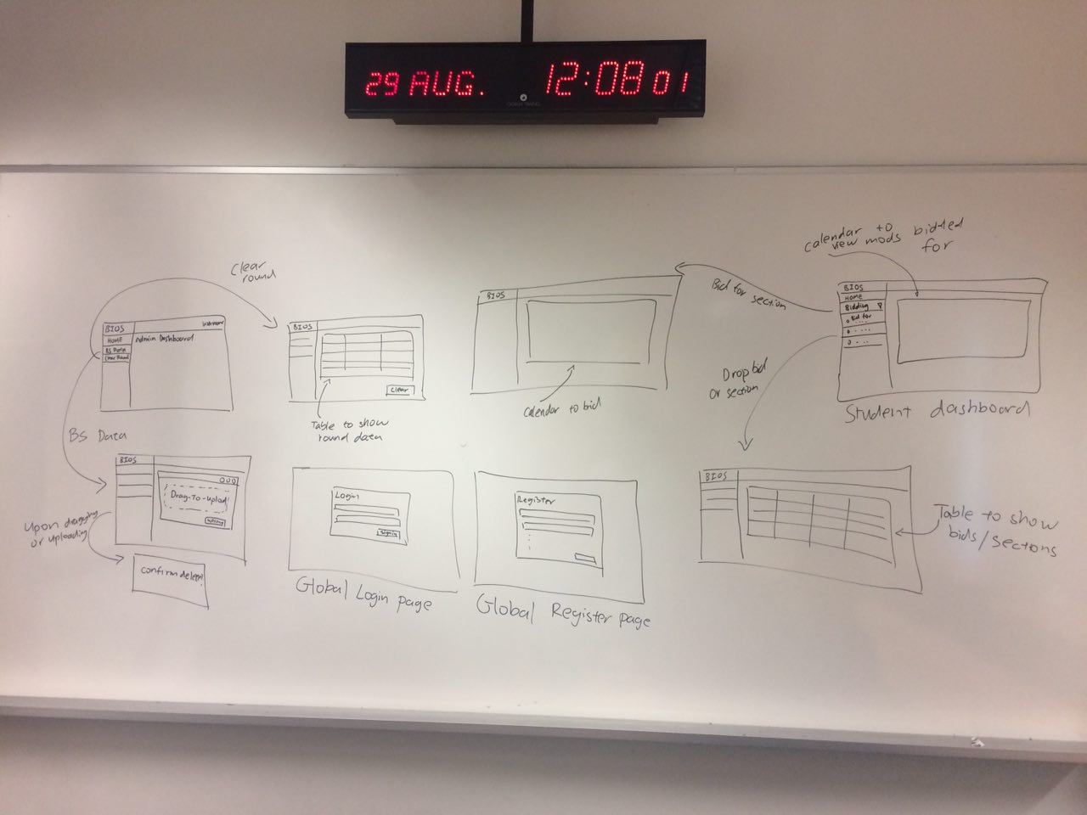

**Appendix B**

This shows the UI skeleton we worked on together, after the UI wireframing. After having learnt Bootstrap together earlier, it was easy for us to work out a great looking skeleton as documented below. A bootstrap theme and framework was used in the making.

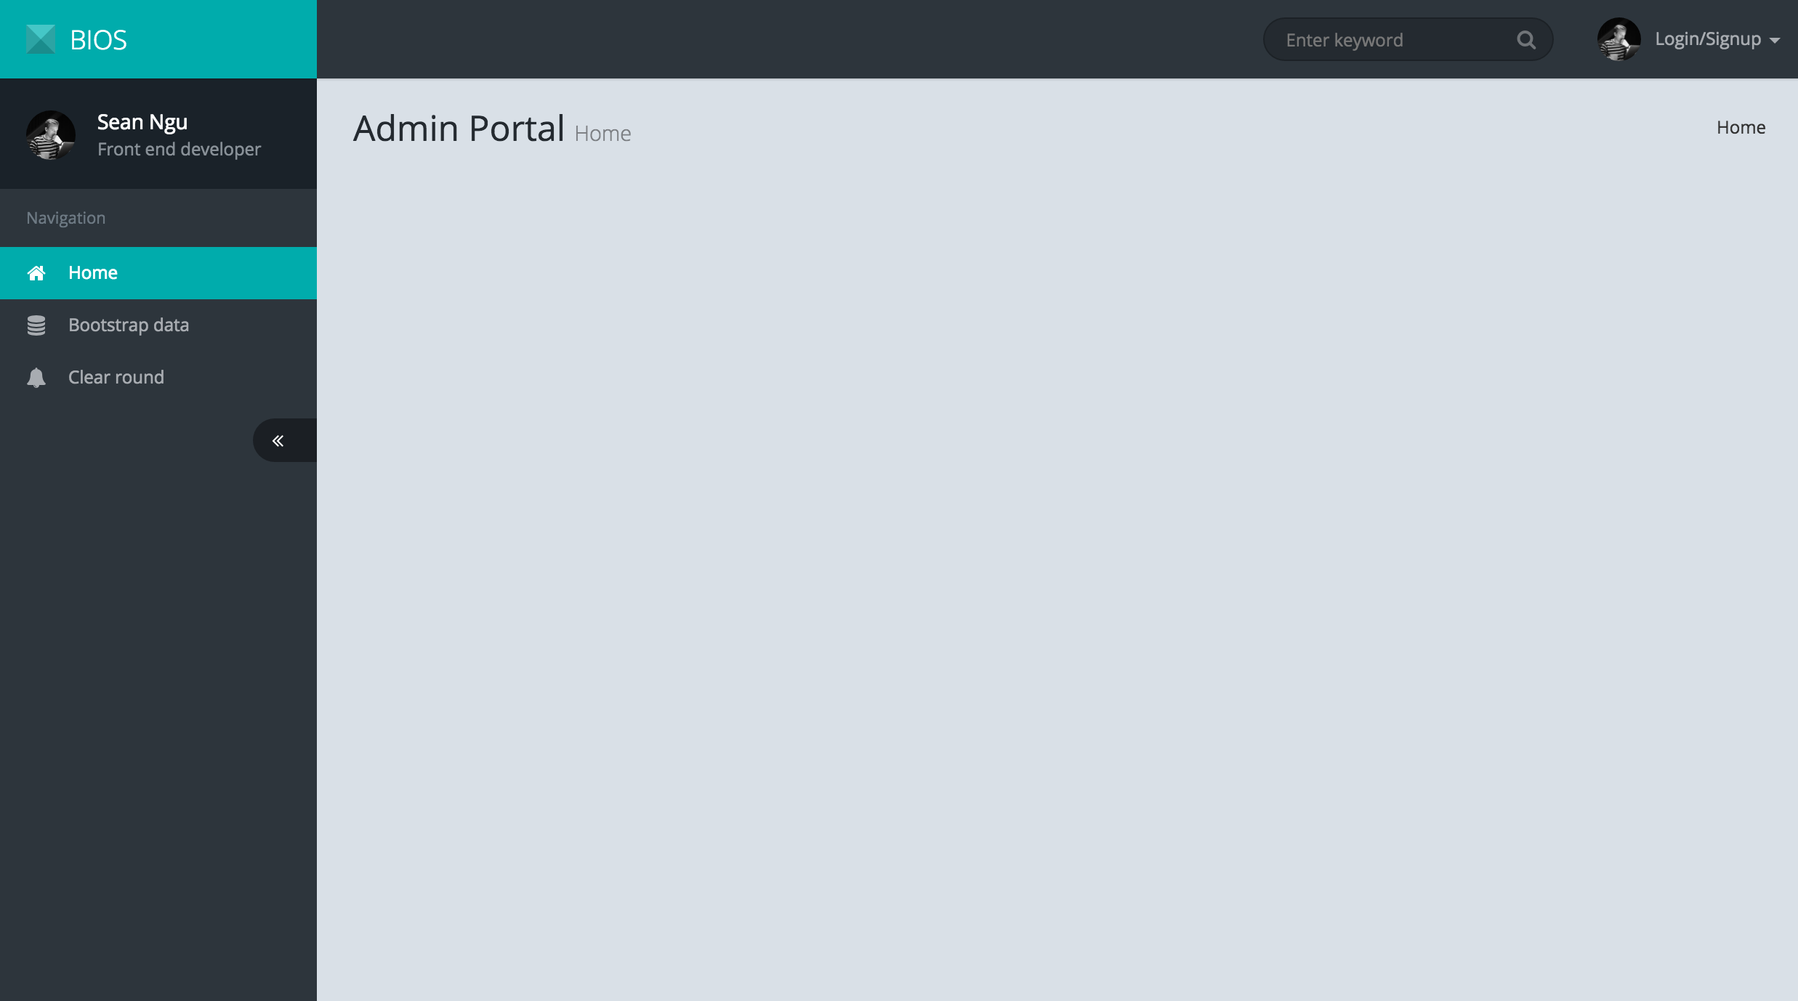

This is the Admin Portal Layout. We’ve identified the functionalities needed, and include it in the side bar.

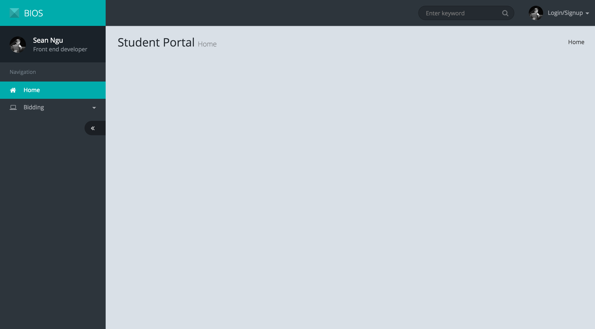

This is the Student Portal Layout. We’ve identified the functionalities needed, and include it in the side bar.

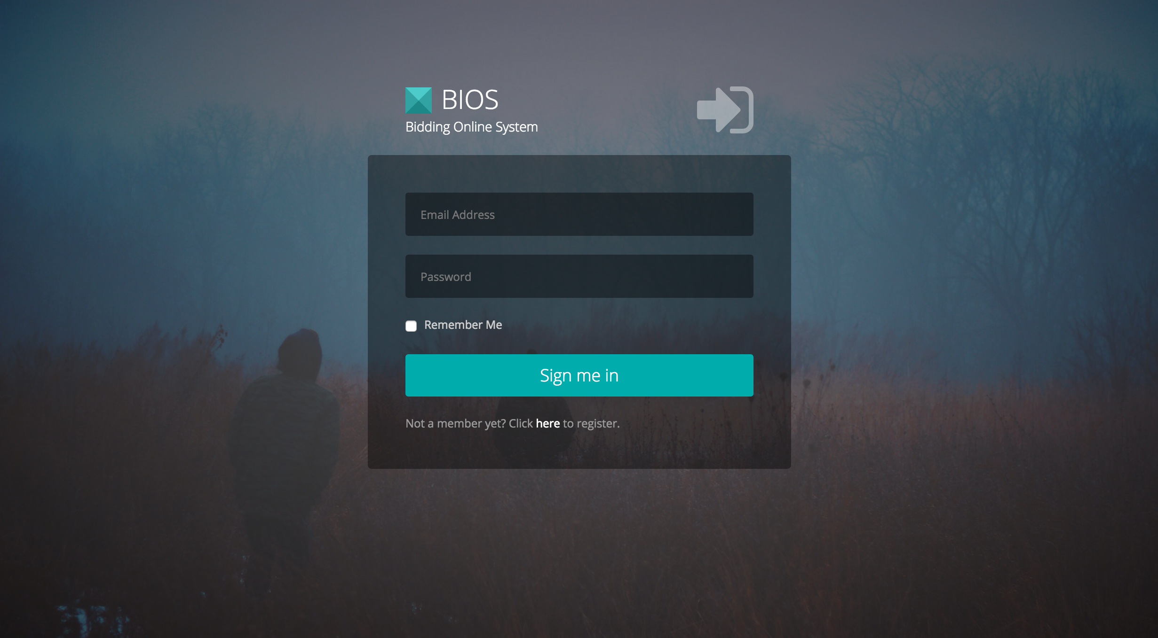

This is the Global login system. For now, only a username and password need be added in.